# Scenario 1: Bug Test – Fine Calc Incorrect

## Scenario Description

* To have reliable replication of the bug (Incorrect calculation of fine, fine is half the amount intended.)
* Test scenarios (aka test set or test suite) are a set of test scripts that cover a specific functional area, business process, use case, etc…
* For example, a given test scenario might cover an order placed on a web site by an existing customer (another scenario might cover orders placed by new customers) – test scripts within the scenario might cover a single item order, a multiple items order, quantity not on hand exception, etc…

## Version Control

|  |  |  |  |
| --- | --- | --- | --- |
| Version # | Date | Author | Description |
| 0.1 | 18/10/2020 | Timothy Pickard | Draft |
| 1.0 | 01/10/2006 | Timothy Pickard | Initial Version |

## Test Scripts

The following scripts will cover this scenario:

* 1.0 return
* 1.2 returnBookAutomatedTest

## Use Case

* Return a book that is one day overdue

## Test Components/Requirements

This test scenario covers the following high-level test requirements (see scripts below for specific requirements covered by each test script):

* That a book exists in the library
* That a patron exists in the library
* That book has been borrowed

## User Groups

* Librarian
* Developer

## Script #: 1.0 Return

### Script Description

* The user will create a book, a patron and will then borrow the books.
* The user will then increment the date so it is 2 days past the loan due date
* Return the book.

### Setup

* Create a book, title t, author a, cNo c1
* Create a patron, name t, last j. (dummy email and phone number)
* Take out loan with those book details (with current date on library)
* Result of the following should be 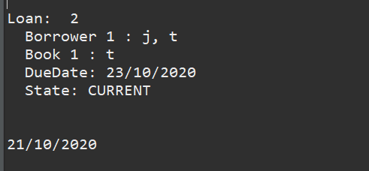

### Teardown

* Testing

### Script Steps

| **Step #** | **Test Action** | **Expected Results** | **Pass/ Fail** |
| --- | --- | --- | --- |
| 1 | Load Main class | Main menu for library system should load | Pass |
| 2 | Increment Date by 3 days | The date should show 2 days ahead of the due date | Pass |
| 3 | Type “r” into the main menu screen | The return book screen should be listed. | Pass |
| 4 | Type in the book number. | The scanning operation should complete | Pass |
| 5 | The fine should show $2.00 for 2 days overdue | Fine should be 2 as per 1 dollar per day for fine. | Pass |

### Test Execution

|  |  |  |  |  |
| --- | --- | --- | --- | --- |
| Date/Time | Tester | Test ID | Test Phase | Status |
| 18/10/2020 9:31pm | Timothy Pickard | TimTest1 | System Cycle 1 | Passed |
| 18/10/2020 | TimothyPickard | TimAutoTest1 | System Cycle 1 | Failed (See results) |

## Results

Manual test

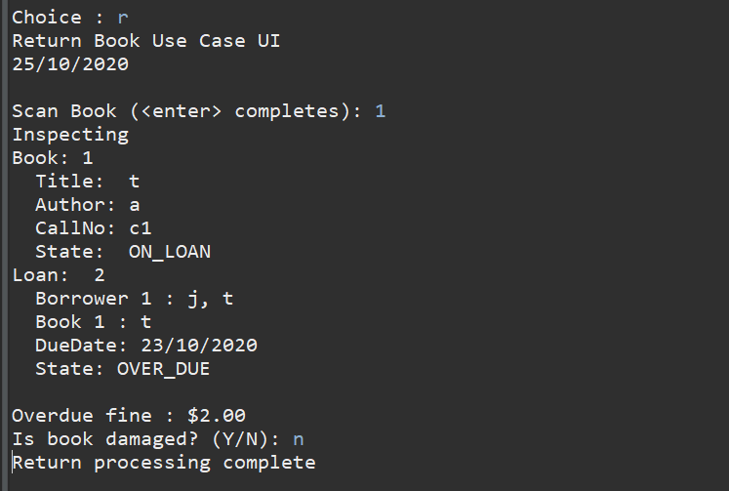

From automated test (with 6 days instead):

